# ABParts User Manual

Version 1.0 | AutoBoss Parts Inventory & Order Management System

## Table of Contents

1. Getting Started
2. Dashboard
3. Organizations
4. Users
5. Parts Catalog
6. Warehouses
7. Inventory Management
8. Orders
9. Machines
10. Reports

## Getting Started

### Logging In

1. Navigate to the ABParts application URL
2. Enter your username and password
3. Click "Login"

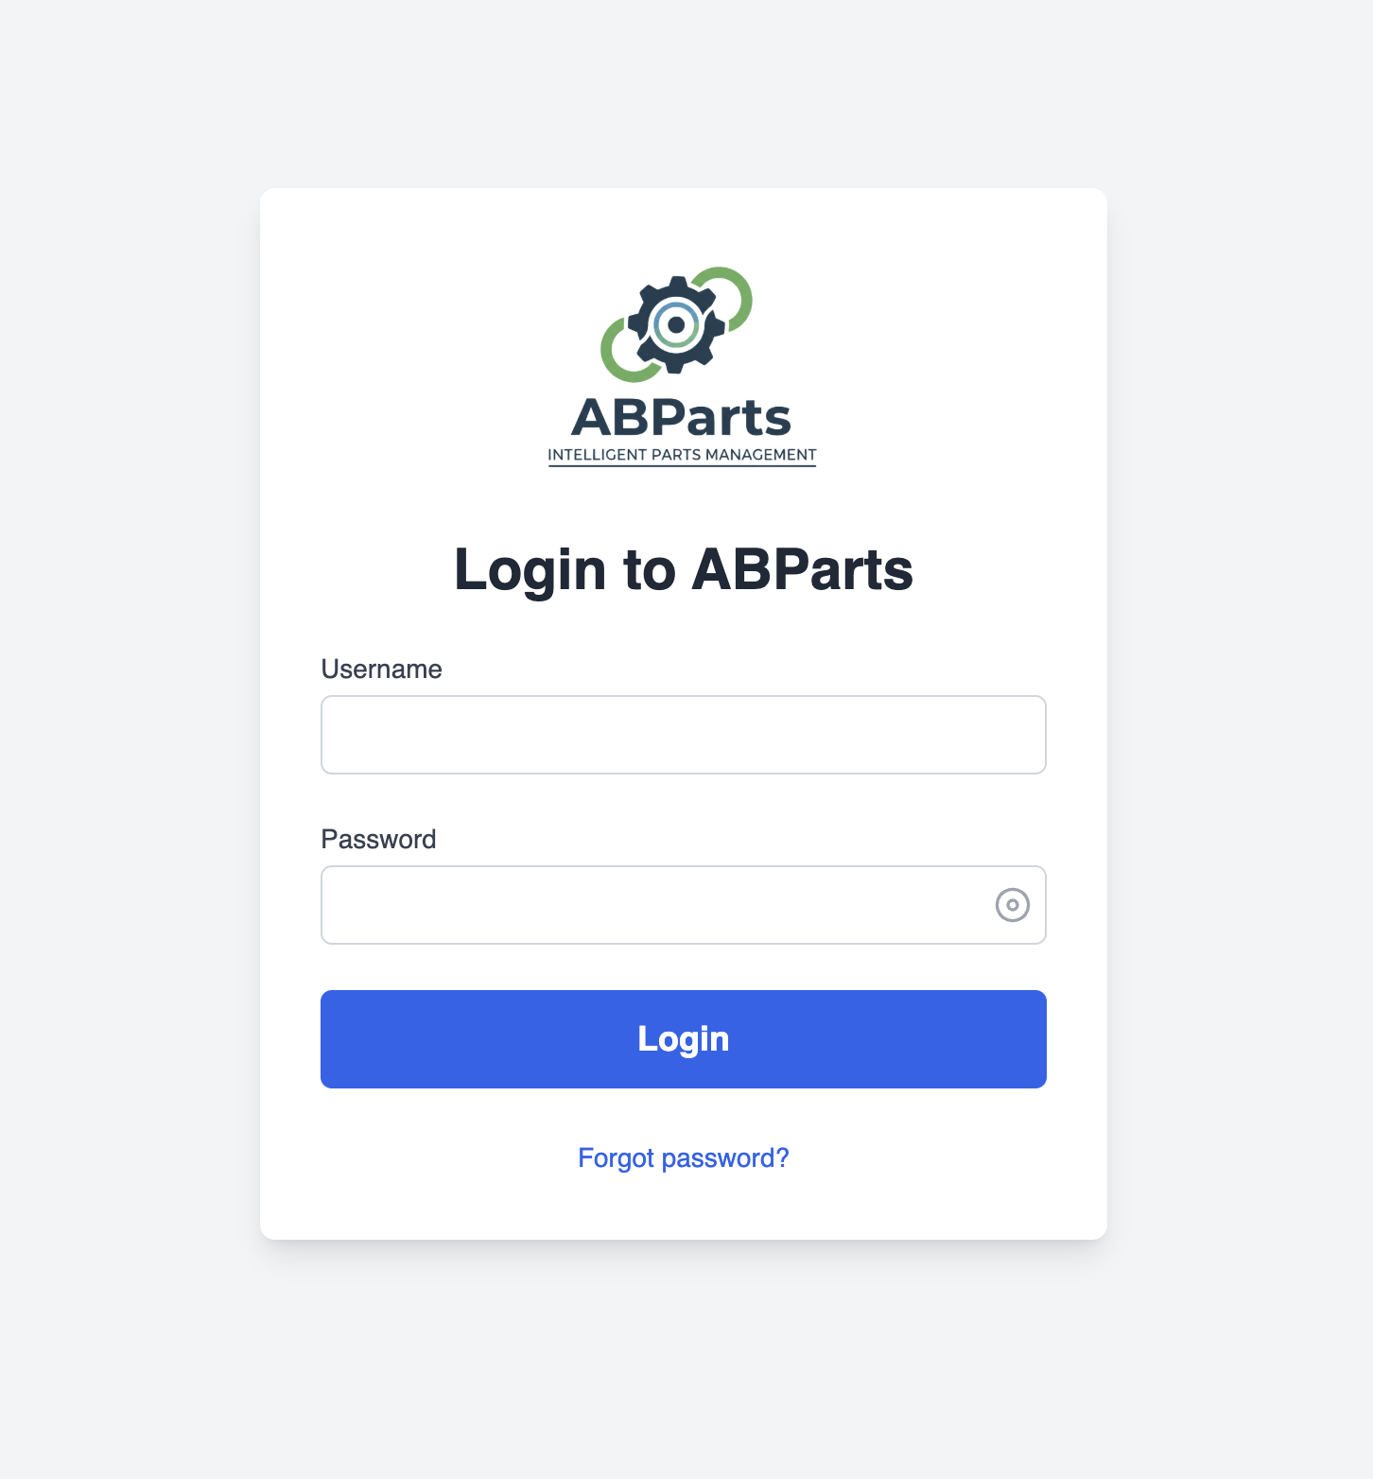

### User Roles

ABParts has three user roles with different permissions:

* Super Admin (Oraseas EE): Full system access, manages all organizations
* Admin: Manages their organization's data, users, and operations
* User: Can view data, place orders, and record machine hours

## Dashboard

The Dashboard provides an at-a-glance view of your organization's key metrics:

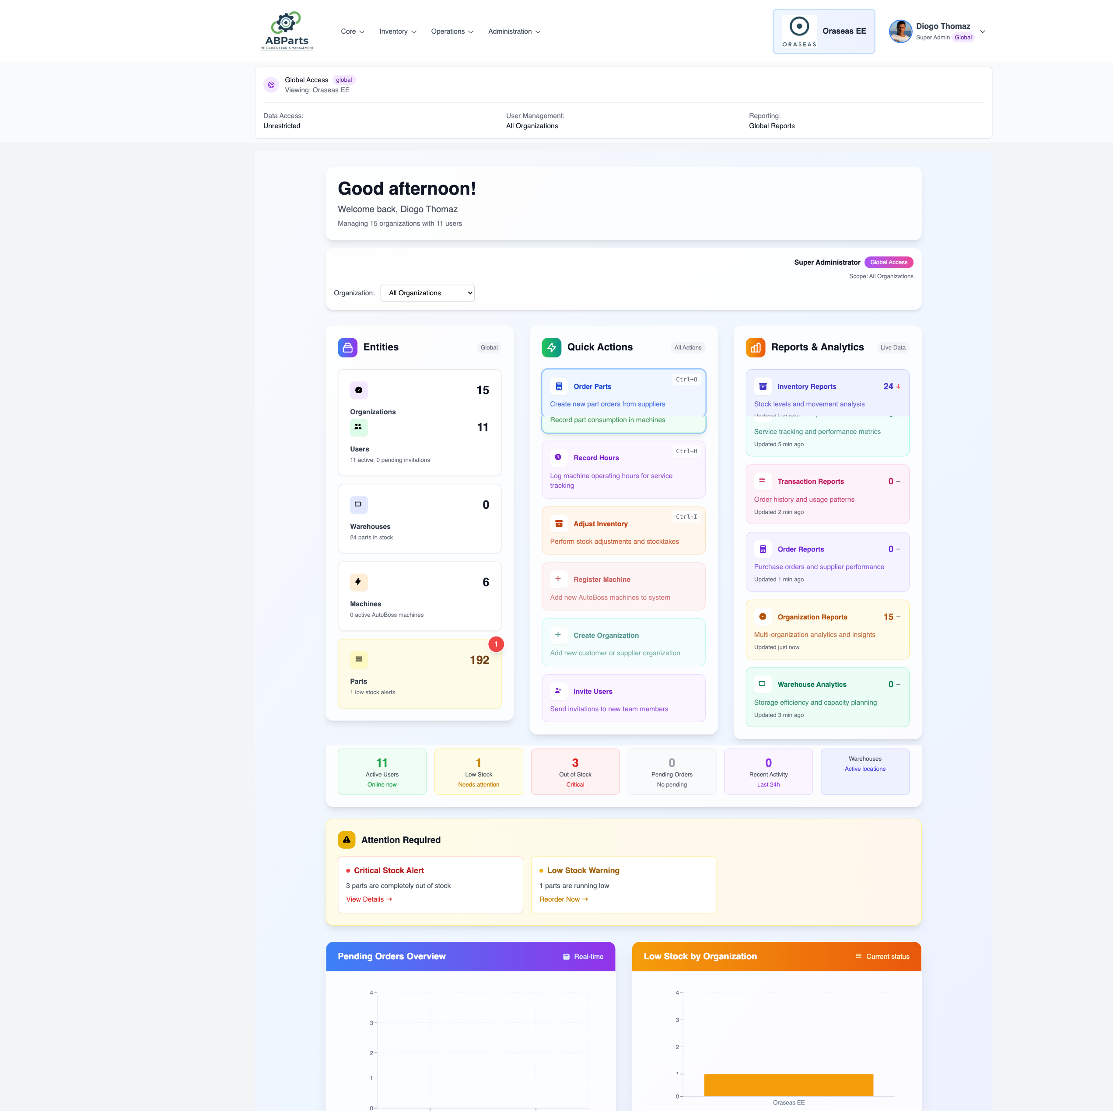

### Key Metrics Displayed

* Inventory Status: Current stock levels and low stock alerts
* Recent Orders: Latest customer and supplier orders
* Machine Status: Active machines and maintenance alerts
* Quick Actions: Shortcuts to common tasks

### Navigation

Use the sidebar menu to access different sections:

* Dashboard
* Organizations (Super Admin only)
* Users
* Parts
* Warehouses
* Inventory
* Orders
* Machines
* Stock Adjustments
* Reports

## Organizations

Available to: Super Admin

### Viewing Organizations

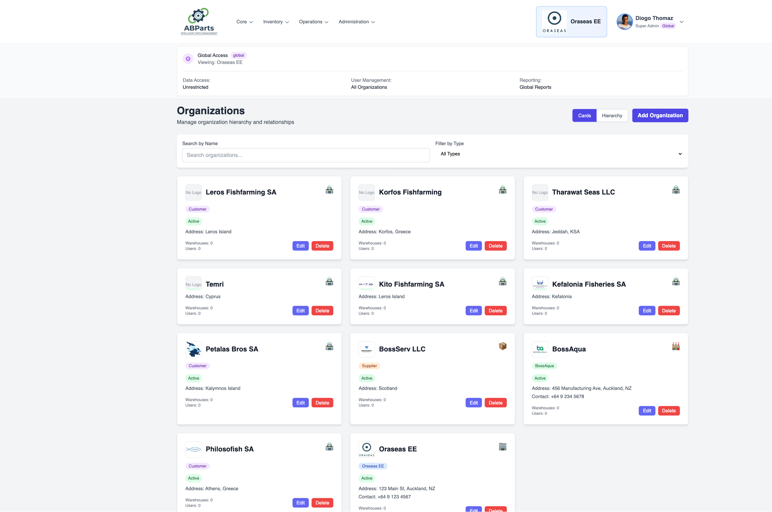

Organizations represent the different entities in the system:

* Oraseas EE: The main distributor
* BossAqua: The manufacturer
* Customer Organizations: Companies that purchase parts

### Organization Details

Each organization has:

* Name and type
* Contact information
* Logo (optional)
* Associated users and warehouses

### Adding a New Organization

1. Click "Add Organization"
2. Fill in organization details:
   * Name
   * Organization Type (Customer, Supplier, etc.)
   * Contact information
3. Upload logo (optional)
4. Click "Create"

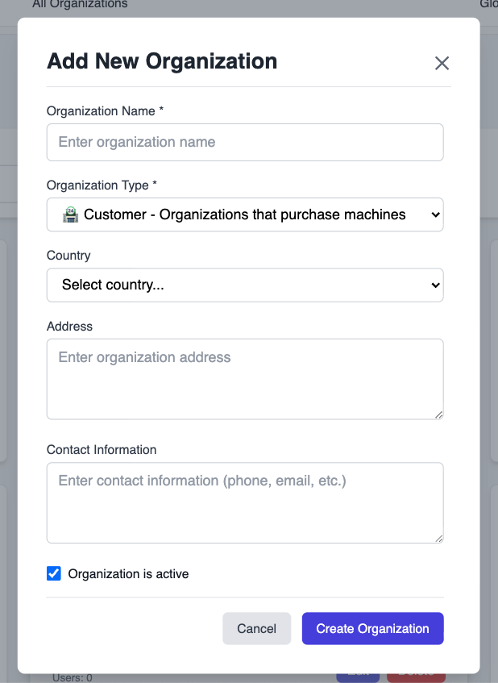

## Users

Available to: Admin and Super Admin

### User Management

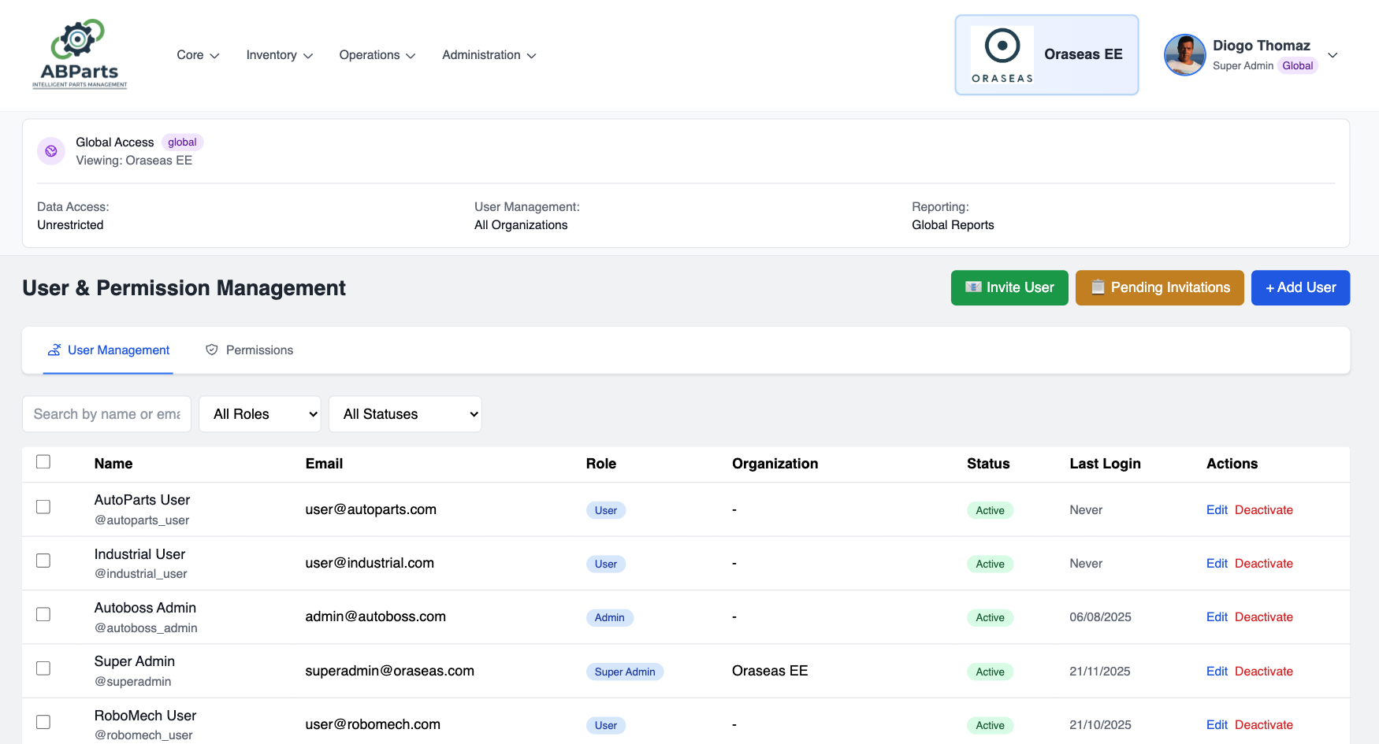

### Adding a New User

1. Click "Add User"
2. Enter user details:
   * Name
   * Username
   * Email
   * Password
   * Role (User or Admin)
   * Organization
3. Click "Create User"

**Editing Users

1. Click the "Edit" button next to a user
2. Update the information
3. Click "Update User"

### User Roles Explained

* User: Can view parts, place orders, record machine hours
* Admin: Can manage users, warehouses, inventory, and orders for their organization
* Super Admin: Full system access (Oraseas EE only)

## Parts Catalog

Available to: All users

### Viewing Parts

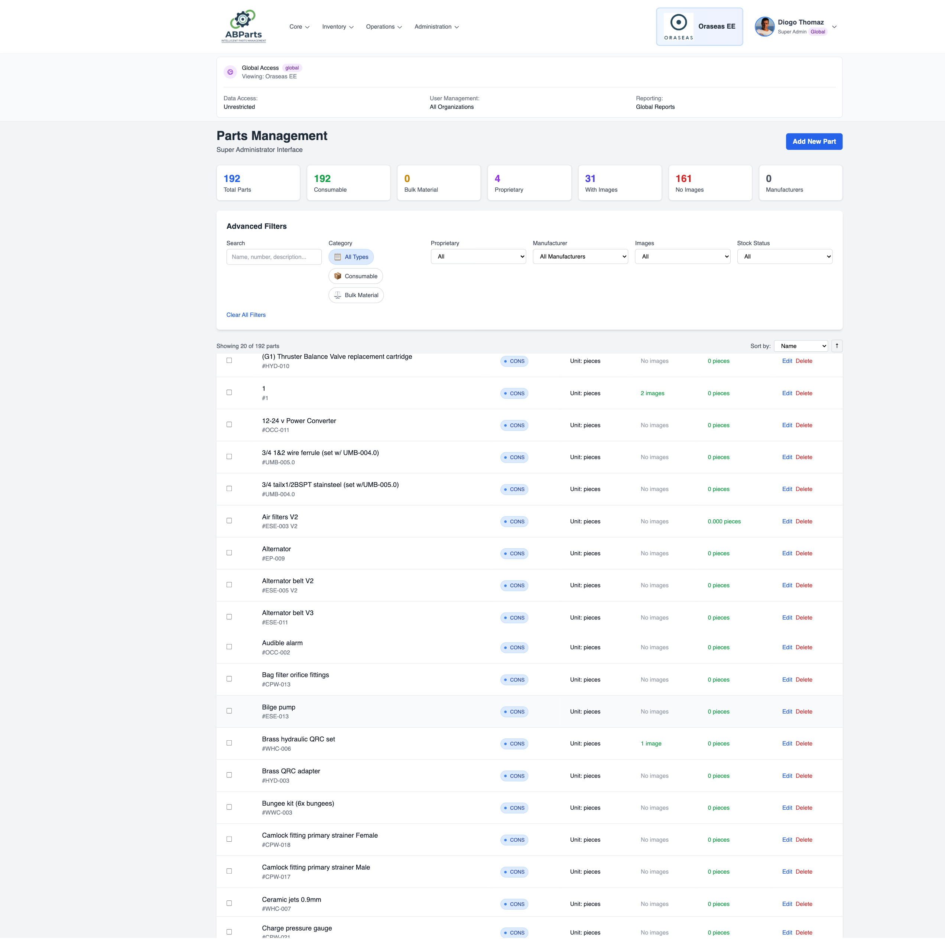

The parts catalog shows all available AutoBoss parts with:

* Part number and name
* Description
* Category
* Unit of measure (pieces, liters, kg)
* Current stock levels

### Searching for Parts

Use the search bar to find parts by:

* Part number
* Part name
* Description
* Category

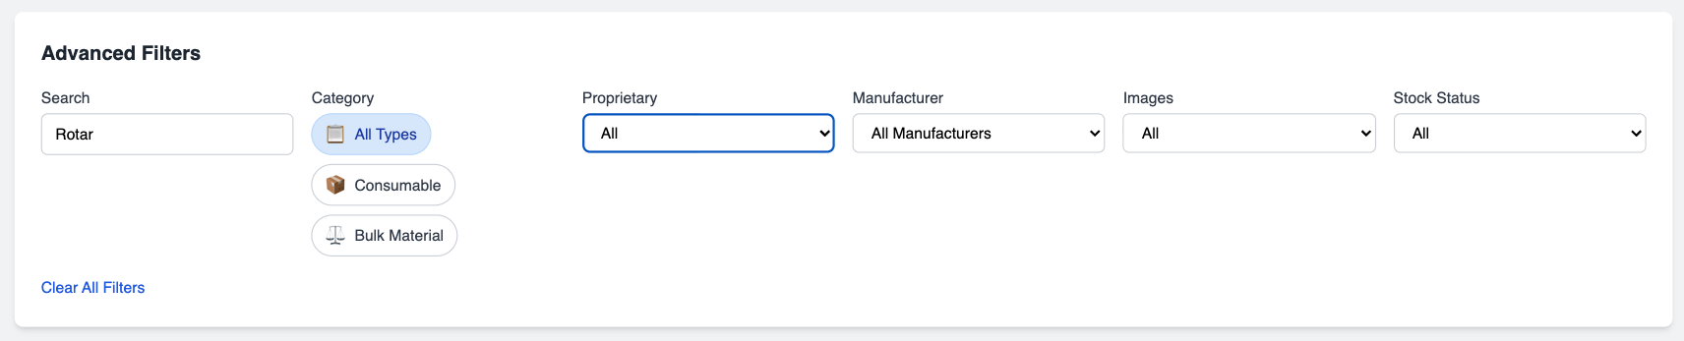

### Part Details

Click on a part to view:

* Full specifications
* Stock levels across warehouses
* Recent transactions
* Usage history

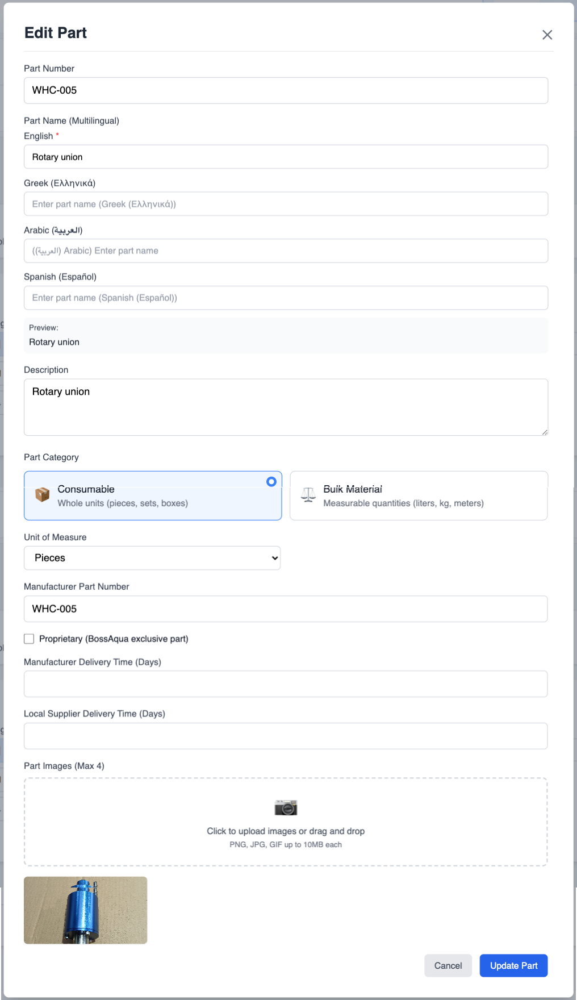

## Warehouses

Available to: Admin and Super Admin

### Warehouse Management

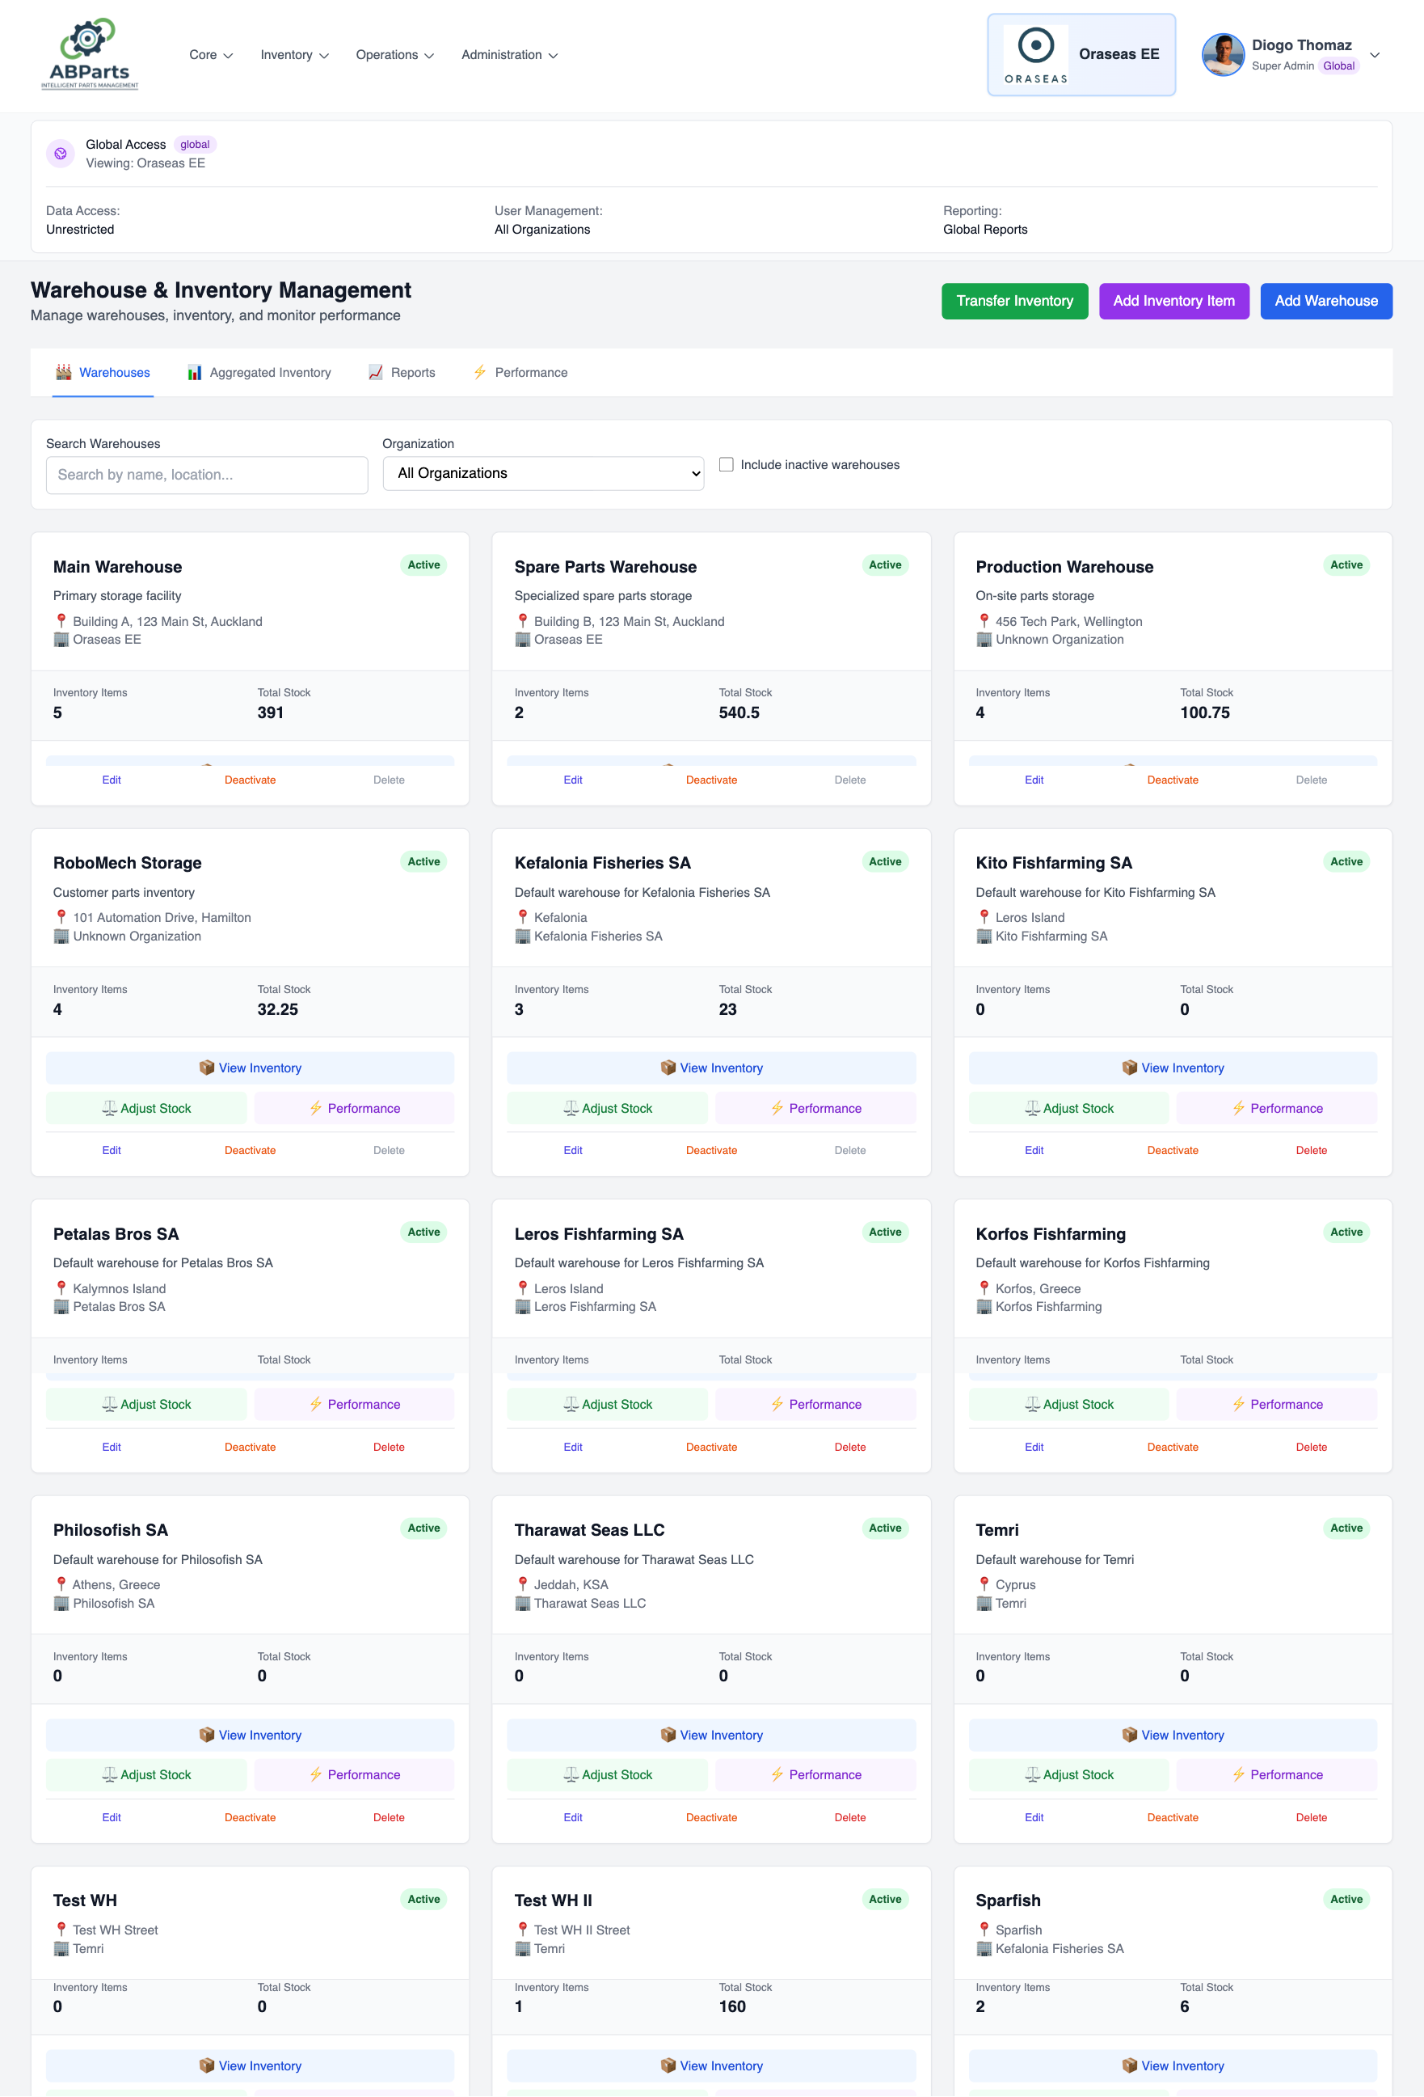

Warehouses are storage locations for parts inventory.

### Adding a Warehouse

1. Click "Add Warehouse"
2. Enter warehouse details:
   * Name
   * Location
   * Organization
3. Click "Create Warehouse"

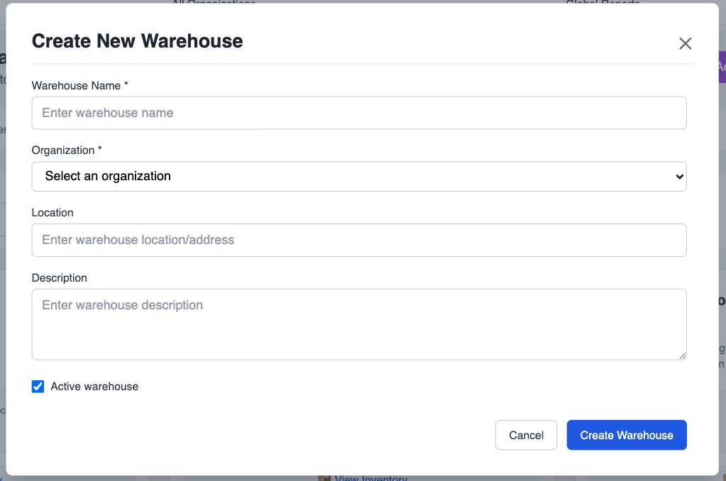

### Warehouse Inventory View

Click on a warehouse to see:

* All parts stored in that warehouse
* Current stock levels
* Low stock alerts
* Recent transactions

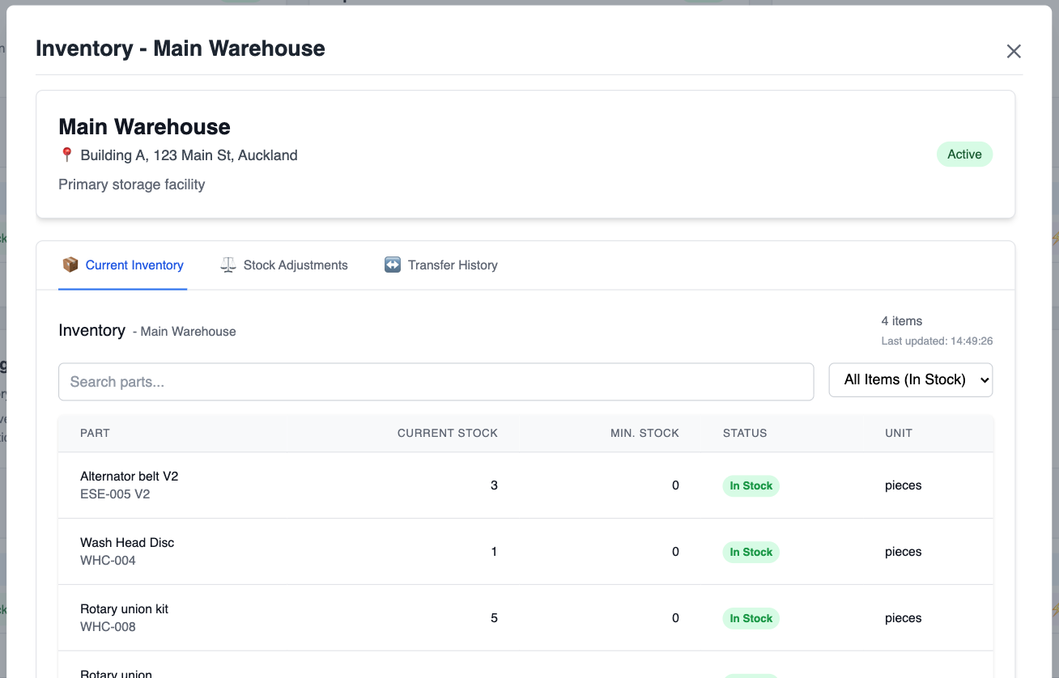

## Inventory Management

Available to: Admin and Super Admin

### Viewing Inventory

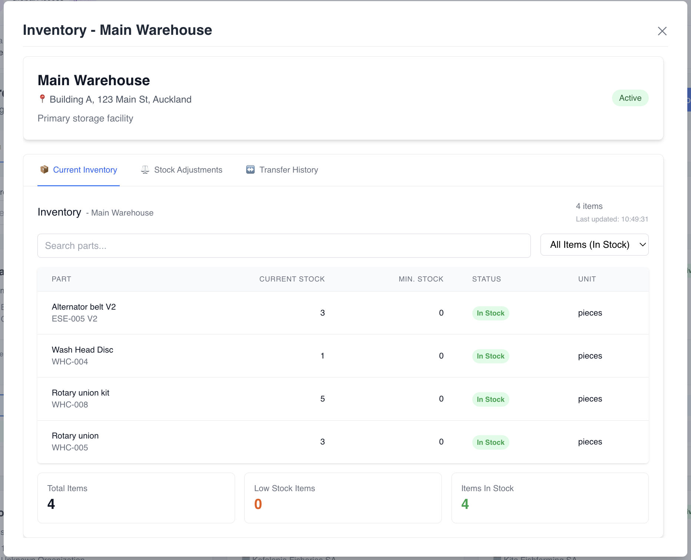

The inventory view shows:

* Current stock levels for all parts
* Warehouse locations
* Low stock warnings
* Recommended reorder quantities

### Stock Adjustments

Use stock adjustments to correct inventory levels or record stock changes.

]

#### Creating a Stock Adjustment

1. Navigate to "Stock Adjustments"
2. Click "Create Stock Adjustment"
3. Select:
   * Warehouse
   * Part
   * Adjustment type (Addition, Removal, Correction, Damage, etc.)
   * Quantity
   * Reason
4. Click "Create Adjustment"

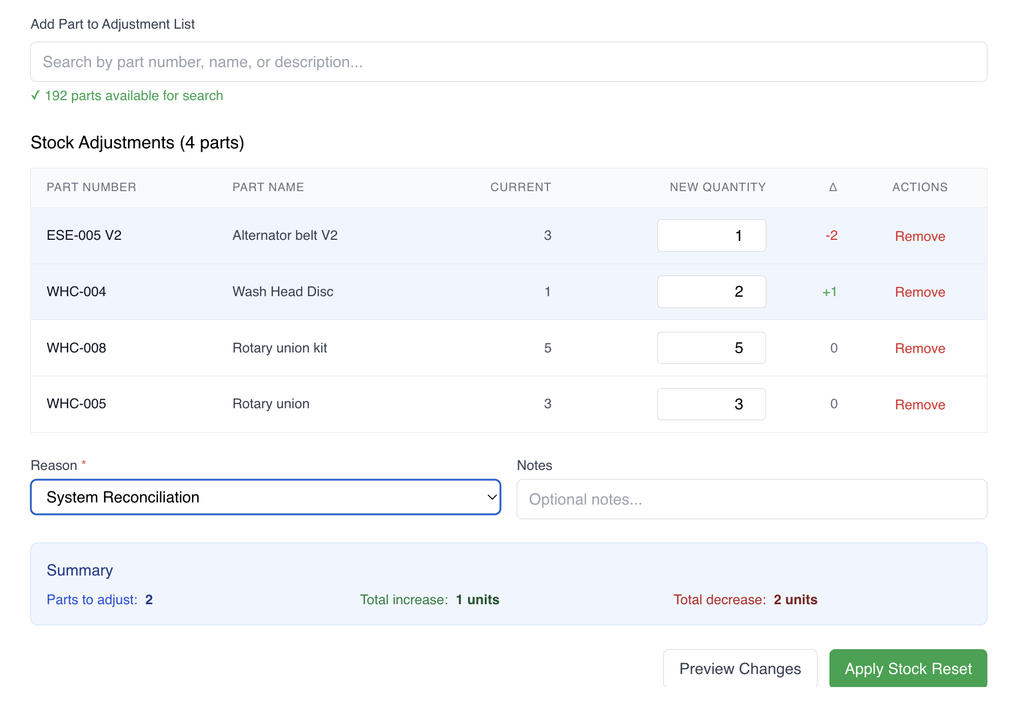

### Inventory Transfers

Transfer parts between warehouses:

1. Go to Warehouses
2. Click "Transfer Inventory"
3. Select:
   * From warehouse
   * To warehouse
   * Part and quantity
4. Add notes (optional)
5. Click "Transfer"

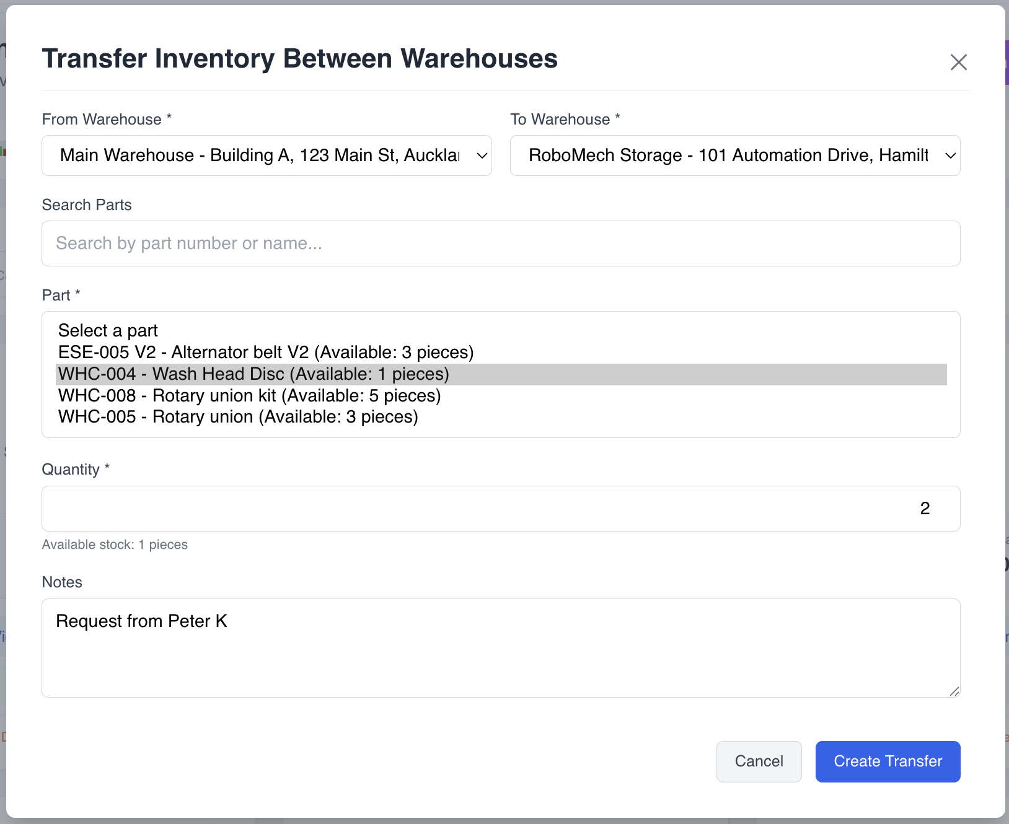

## Orders

Available to: All users (view/create), Admin (manage)

### Order Types

ABParts handles two types of orders:

1. Customer Orders: Orders placed by customers to Oraseas EE
2. Supplier Orders: Orders placed by Oraseas EE to suppliers

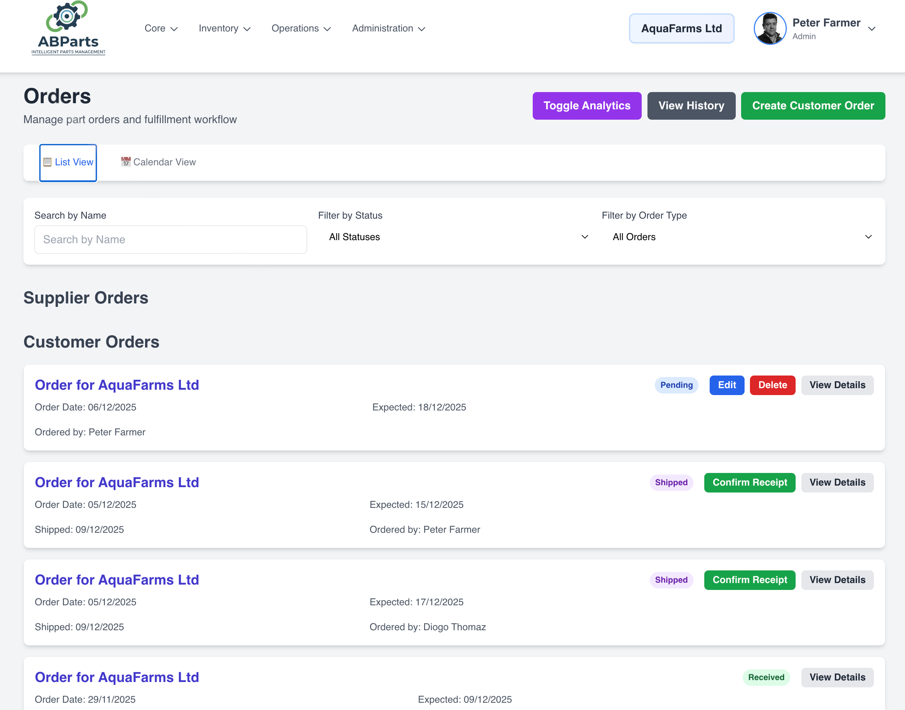

### Placing a Customer Order

1. Navigate to "Orders"
2. Click "Add Customer Order"
3. Fill in order details:
   * Customer organization (auto-filled for non-admin users)
   * Order date
   * Expected delivery date
4. Add order items:
   * Select part
   * Enter quantity
   * Enter unit price (optional)
   * Click "Add Item"
5. Add notes (optional)
6. Click "Create Order"

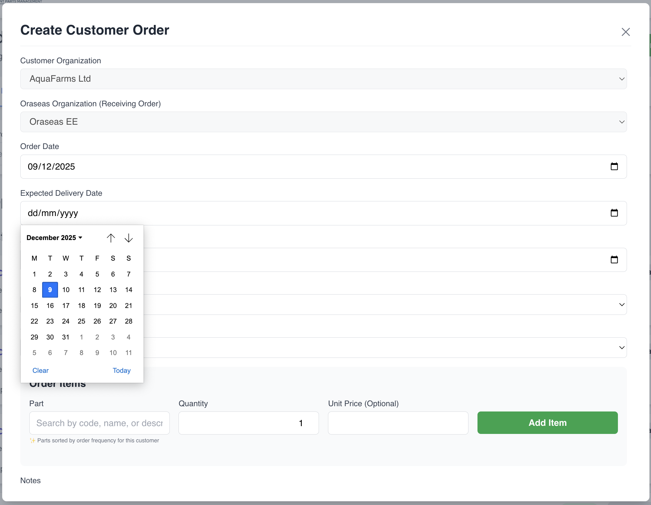

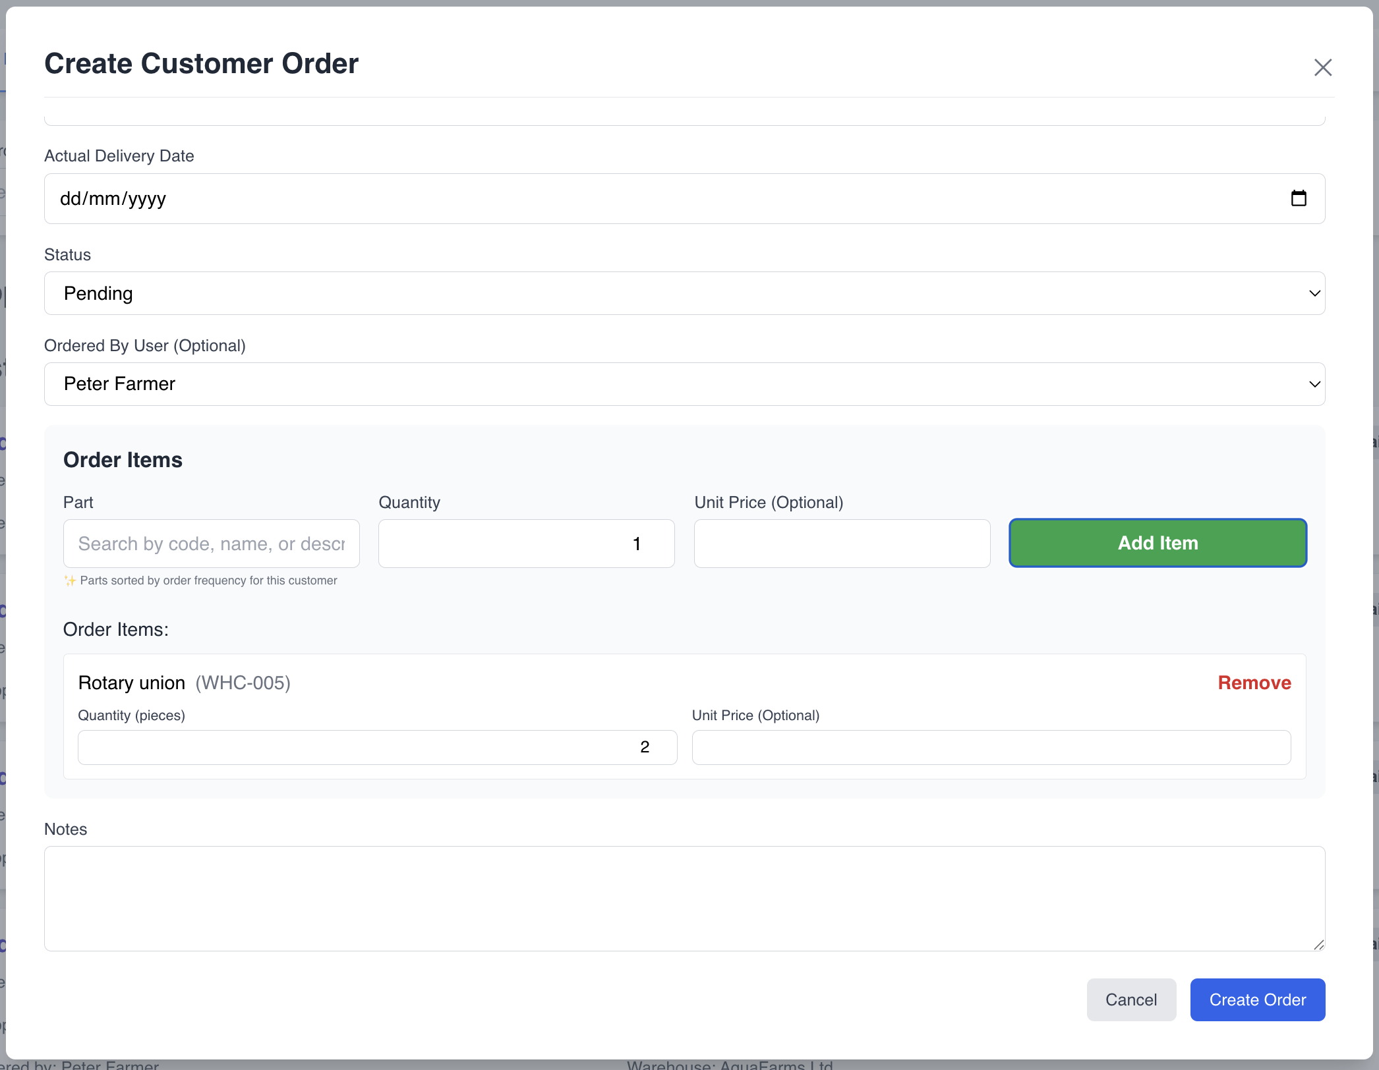

### Placing a Supplier Order

Admin only

1. Navigate to "Orders" → "Supplier Orders" tab
2. Click "Add Supplier Order"
3. Fill in order details:
   * Supplier name
   * Order date
   * Expected delivery date
4. Add order items
5. Click "Create Order"

[SCREENSHOT: Create Supplier Order form]

### Order Status Workflow

Orders progress through these statuses:

Customer Orders:

* Pending: Order placed, awaiting processing
* Shipped: Order shipped by Oraseas EE
* Delivered: Order received by customer
* Cancelled: Order cancelled

Supplier Orders:

* Requested: Order placed with supplier
* Confirmed: Supplier confirmed the order
* Shipped: Supplier shipped the order
* Received: Order received by Oraseas EE
* Cancelled: Order cancelled

### Managing Orders (Admin)

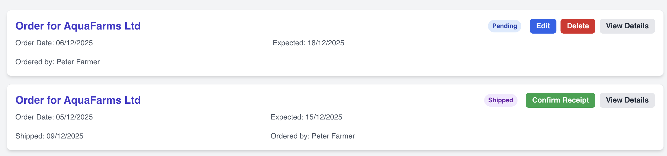

#### Editing an Order

1. Click "Edit" next to an order (only Pending orders can be edited)
2. Modify order details or items
3. Click "Update Order"

#### Deleting an Order

1. Click "Delete" next to an order (only Pending/Requested orders can be deleted)
2. Confirm deletion
3. Order is removed from the system

### Order Calendar View

View orders on a calendar to track delivery dates:

1. Click "Calendar View" on the Orders page
2. Orders are displayed by expected delivery date
3. Click on an order to view details

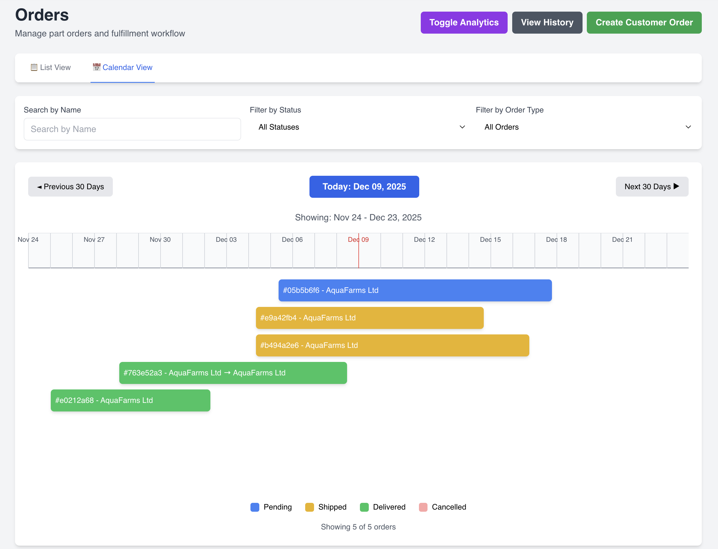

### Shipping Orders (Oraseas EE Admin)

1. Find the order in "Pending" status
2. Click "Ship Order"
3. Enter:
   * Shipped date
   * Tracking number (optional)
   * Notes
4. Click "Ship"

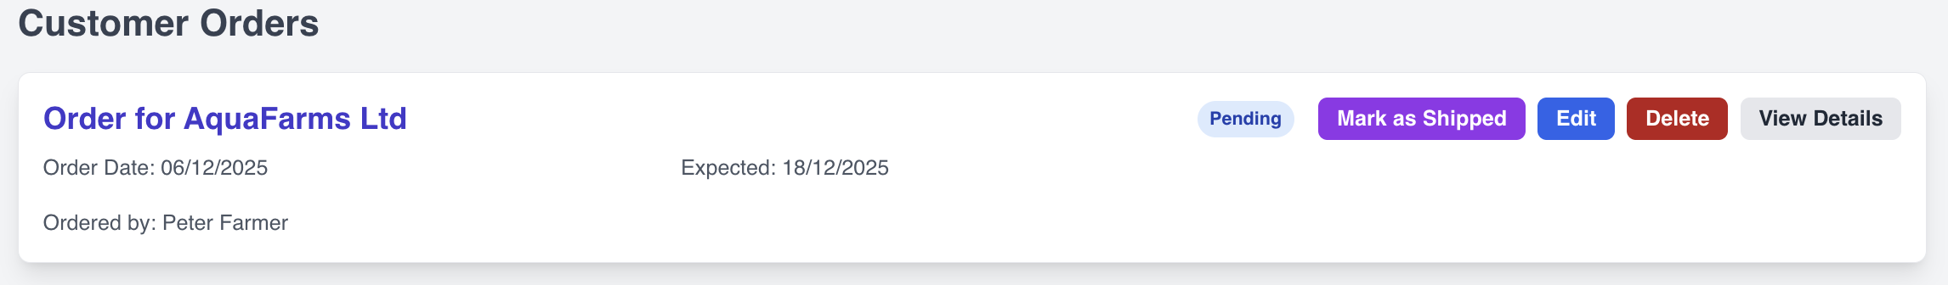

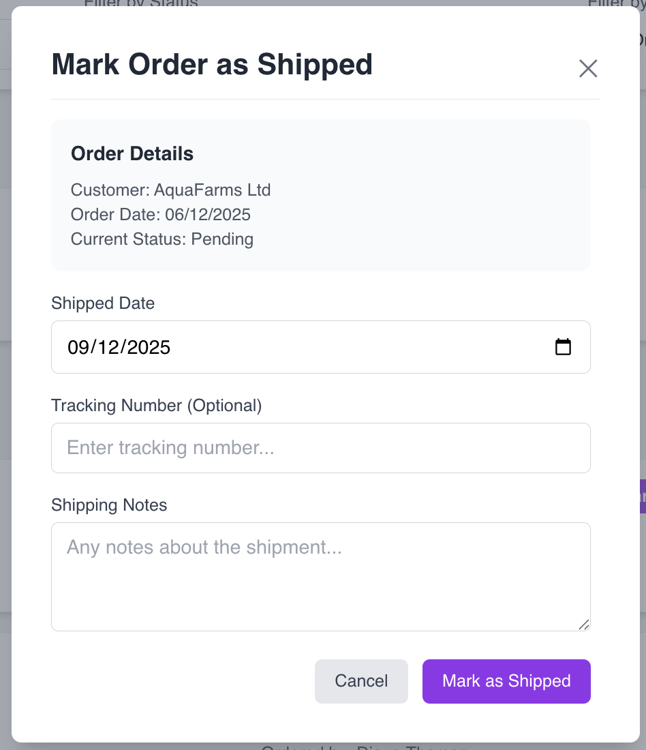

### Confirming Receipt (Customer Admin)

1. Find the order in "Shipped" status
2. Click "Confirm Receipt"
3. Enter:
   * Actual delivery date
   * Receiving warehouse
   * Notes
4. Click "Confirm Receipt"

The system automatically updates inventory in the selected warehouse.

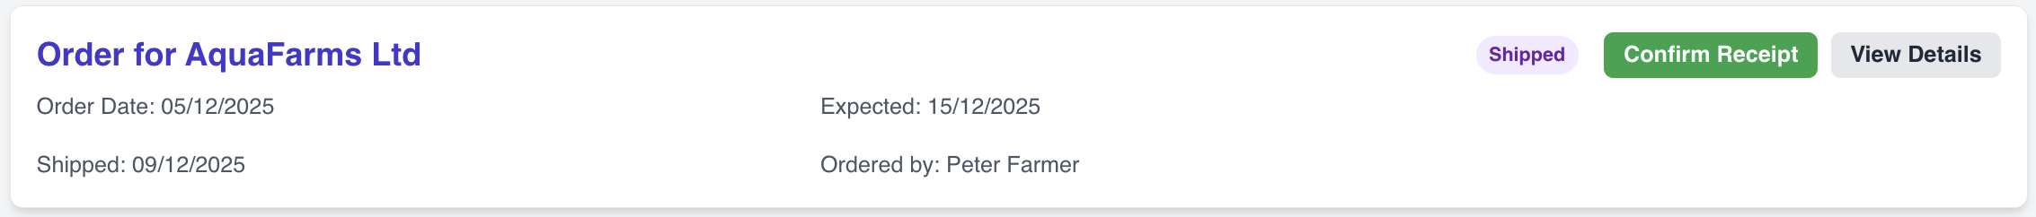

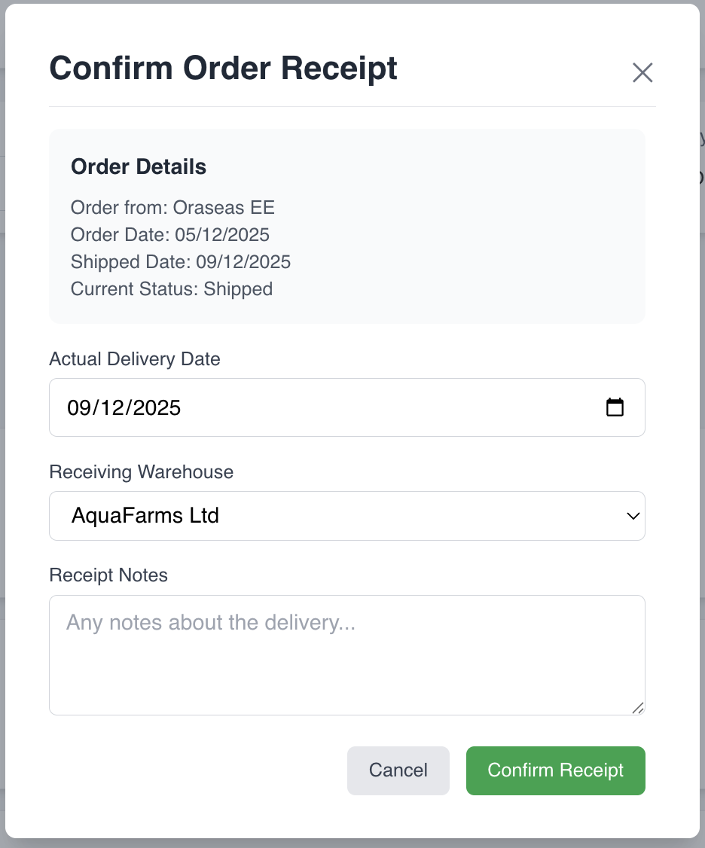

## Machines

Available to: All users

### Machine Management

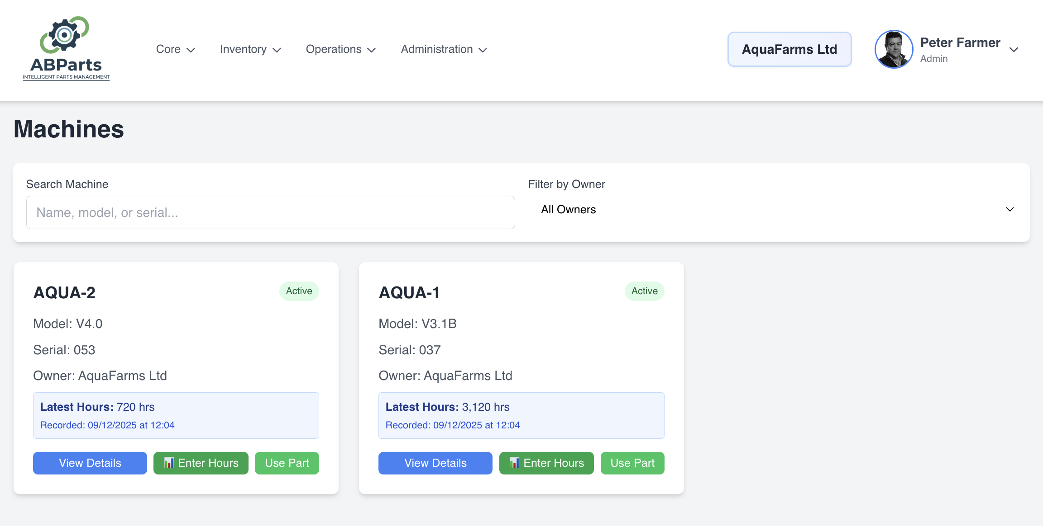

Track AutoBoss machines deployed at customer locations.

### Registering a Machine

1. Navigate to "Machines"
2. Click "Add Machine"
3. Enter machine details:
   * Serial number
   * Model
   * Installation date
   * Location
   * Organization
4. Click "Register Machine"

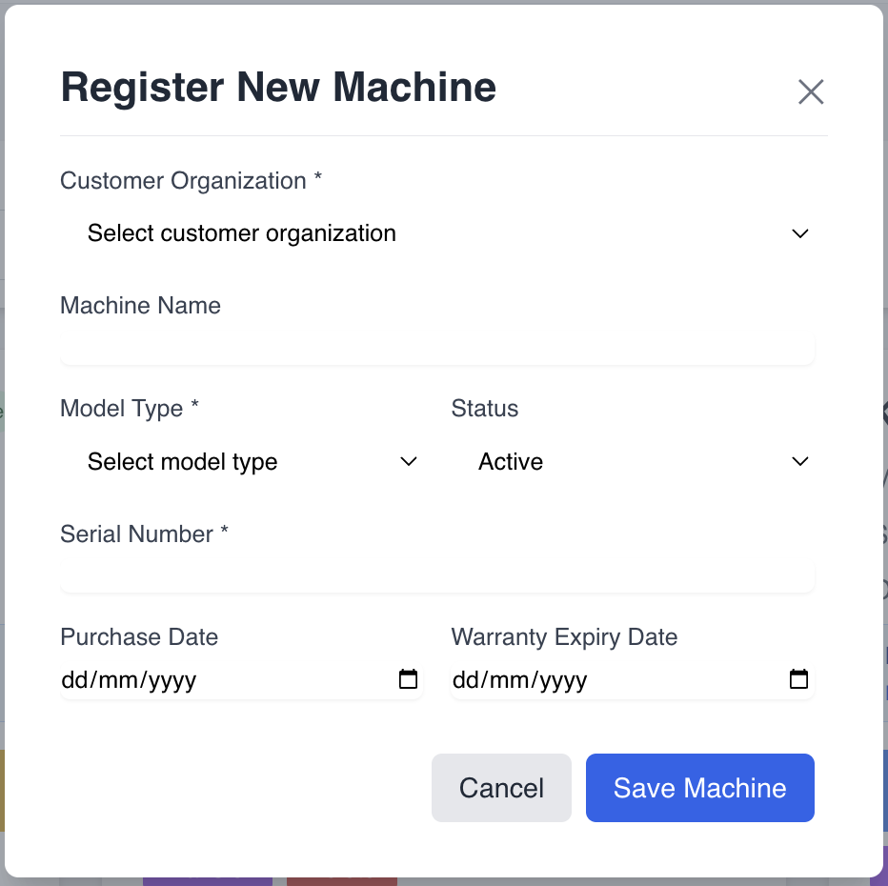

### Recording Machine Hours

Users can record operating hours for machines:

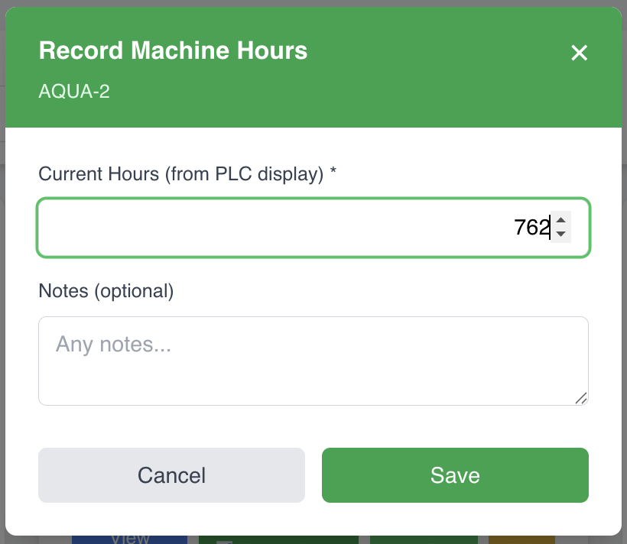

#### Quick Hour Recording

1. Find the machine in the list
2. Click the "Record Hours" button
3. Enter current hour meter reading
4. Click "Save"

#### Detailed Hour Recording

1. Click on a machine to view details
2. Click "Record Hours"
3. Enter:
   * Current hour meter reading
   * Date
   * Notes (optional)
4. Click "Record"

### Machine Hour History

View the complete history of hour recordings for each machine:

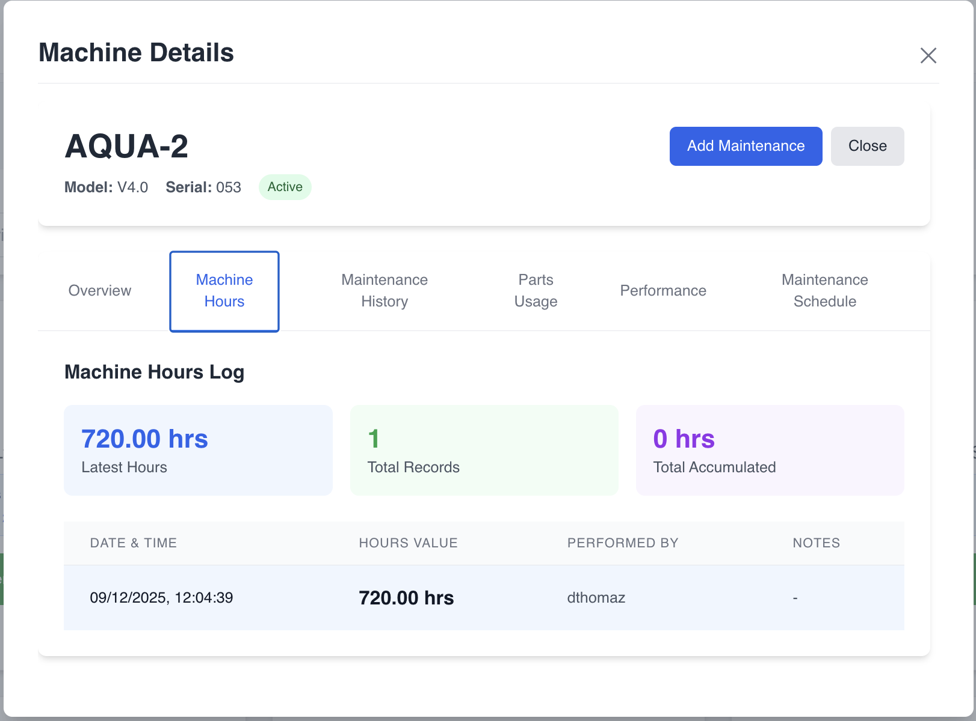

### Maintenance Reminders

The system shows maintenance reminders based on:

* Hours since last maintenance
* Time since last maintenance
* Recommended maintenance intervals

[SCREENSHOT: Maintenance reminder notification]

## Reports

Available to: Admin and Super Admin

### Available Reports

[SCREENSHOT: Reports page]

#### Inventory Reports

* Current stock levels by warehouse
* Low stock alerts
* Stock movement history
* Inventory valuation

#### Order Reports

* Order history by date range
* Order status summary
* Customer order patterns
* Supplier performance

#### Machine Reports

* Machine utilization
* Maintenance history
* Hour meter readings
* Machine performance metrics

### Generating a Report

1. Navigate to "Reports"
2. Select report type
3. Choose filters:
   * Date range
   * Organization
   * Warehouse
   * Part category
4. Click "Generate Report"
5. Export to PDF or Excel (if available)

[SCREENSHOT: Report generation interface]

## Tips & Best Practices

### For All Users

* Keep information current: Update machine hours regularly
* Use search: Use the search function to quickly find parts
* Check notifications: Review alerts for low stock and maintenance reminders

### For Admins

* Review orders daily: Process pending orders promptly
* Monitor inventory: Check low stock alerts and reorder as needed
* Maintain user accounts: Keep user information up to date
* Regular stock checks: Perform periodic physical inventory counts and adjust as needed

### For Super Admins

* User management: Regularly review user access and permissions
* System monitoring: Check system health and performance
* Data integrity: Ensure organizations and warehouses are properly configured

## Troubleshooting

### Common Issues

Can't log in

* Verify username and password
* Check with your administrator if account is active
* Clear browser cache and try again

Can't see certain features

* Check your user role - some features are role-restricted
* Contact your administrator for permission changes

Order not updating inventory

* Ensure order status is "Delivered" or "Received"
* Verify receiving warehouse is selected
* Check with administrator if issue persists

Parts not showing in search

* Check spelling and part number
* Try searching by category
* Verify part exists in the system

## Support

For technical support or questions:

* Email: [support@oraseas.com](mailto:support@oraseas.com)
* Phone: [Contact Number]
* System Administrator: [Admin Name/Contact]

## Appendix

### Keyboard Shortcuts

* Ctrl/Cmd + K: Quick search
* Esc: Close modal dialogs
* Tab: Navigate between form fields

### Part Categories

* Filters
* Chemicals
* Consumables
* Spare Parts
* Accessories

### Unit of Measure

* pieces: Countable items (filters, parts)
* liters: Liquids (chemicals, cleaning solutions)
* kg: Weight-based items (powder, granules)

Document Version: 1.0  
Last Updated: December 2025  
For: ABParts Inventory Management System